MoboTrex is proud to congratulate our partner, Termico Technologies, in being awarded the winner of the 2021 Coolest Thing Made In Illinois contest. MoboTrex is the exclusive master distributor of the Eagle Heated Traffic Signal Visors manufactured by Termico Technologies. Please see the news stories and press release below for more information about this amazing product and contest.
AP News - Illinois-made ‘Coolest Thing’ keeps ice off traffic lights
KHQA-TV - Traffic signal heater named coolest thing made in Illinois

Traffic Signal Heater Named Coolest Thing Made in Illinois
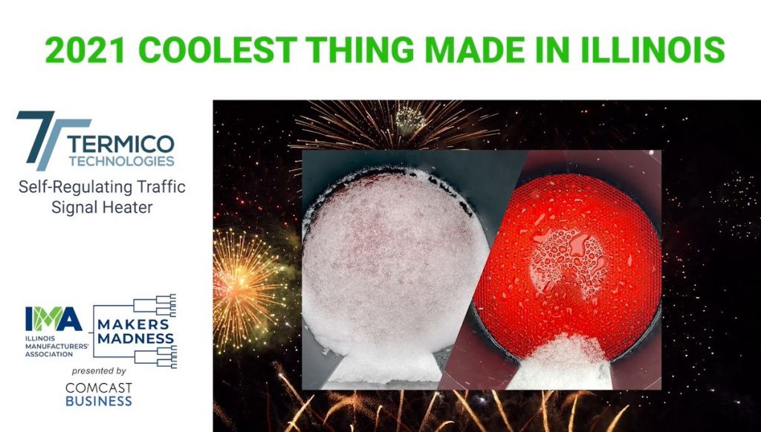
Made by Termico Technologies in Elk Grove Village, Champion of “Makers Madness” Contest Saves Lives and Keeps Roads Safe
SPRINGFIELD – Following eight weeks of rigorous competition, the Self-Regulating Traffic Signal Heater manufactured by Termico Technologies in Elk Grove Village has been declared the winner of the second annual “Makers Madness” contest, earning the title of The Coolest Thing Made in Illinois.
Presented by Comcast Business, the competition shines a light on Illinois’ diverse manufacturing sector, which has played a critical role in the state and nation’s response to the coronavirus pandemic. Manufacturers are developing life-saving vaccines and treatments, producing needed personal protective equipment, keeping store shelves stocked with important goods and nutritious foods, and powering our homes and businesses.
Manufactured by Termico Technologies in Elk Grove Village, the Self-Regulating Traffic Signal Heater uses conductive particles to heat traffic signals so they remain visible and free of ice and snow so traffic can safely navigate our roadways. As municipalities and departments of transportation around the country have transitioned away from traditional traffic signals to new LED versions, this innovative technology has become vital to protecting motorists and ensuring our transportation system continues to operate efficiently during winter weather.
Voters chose the Self-Regulating Traffic Signal Heater from a field of 311 individual products initially nominated from across the state, with over 300,000 votes cast over the course of the competition.
“The Self-Regulating Traffic Signal Heater is an outstanding example of the innovation and ingenuity of our state’s manufacturing sector and has rightfully earned the title of The Coolest Thing Made in Illinois. This unique energy efficient product from Termico Technologies impacts our lives every day by making sure the people and goods that travel on our roadways get where they’re going safely and efficiently,” said Mark Denzler, president and CEO of the Illinois Manufacturers’ Association. “Manufacturing has always played a vital role in Illinois, especially during the pandemic when manufacturers ramped up production to produce supplies needed to combat the virus. The men and women on factory floors across the state deserve our recognition and appreciation and the Illinois Manufacturers’ Association is proud to advocate on their behalf each and every day.”
U.S. Sen. Dick Durbin joined the IMA in a virtual awards ceremony at www.makersmadnessil.com to help announce the winner of the contest.
“Manufacturing is a cornerstone of our state’s economy and this contest is a wonderful showcase for the many innovative products made here in the Land of Lincoln,” said U.S. Senator Dick Durbin (D-IL). “Time and again, manufacturers have risen to the challenge, including playing a vital role in responding to the COVID-19 pandemic over the past year. I’d like to extend my congratulations to all the participating businesses and to the Illinois Manufacturers’ Association and its partners for the success of this year’s Makers Madness Contest.”
“Seeing Makers Madness unfold first-hand has been really exciting, and Comcast Business is proud to help the IMA make it happen,” said Sean McCarthy, Comcast’s Regional Vice President of Business Development and Strategic Initiatives. “The contest created a showcase for Illinois manufacturers and the innovative products they’re bringing to the world stage. Congratulations to Termico Technologies for earning the title of The Coolest Thing Made in Illinois this year.”
Statewide, manufacturing generates more than $304 billion in economic output, contributing 12 percent to the state’s Gross Domestic Product – the largest share of any industry in Illinois. Manufacturers employ 556,300 women and men in Illinois at an average salary of $88,691, providing $52 billion in wages and benefits.
Though manufacturing remains an economic powerhouse in Illinois, manufacturers here and across the country are facing the threat of an aging workforce. Over the next decade, it is estimated that 300,000 men and women will leave the industry as baby boomers begin to retire, presenting numerous career opportunities. Nationally, there are 460,000 open manufacturing jobs today.
“We are honored and proud to have the Termico Technologies Self-Regulating Traffic Signal Heater win the IMA’s 2021 Coolest Thing Made in Illinois Contest. Our traffic safety innovation keeps drivers safe and saves lives by eliminating the snow and ice buildup on LED traffic signals,” said Mike Cubon, Chief Technical Officer at Termico Technologies. “We would like to thank the entire Tramec Family and the many others who have supported Termico Technologies throughout this incredible experience. We would also like to thank all of the other Illinois manufacturers whose products and innovations have made this a fun and competitive contest. Lastly, we would like to thank the IMA and Comcast Business for holding this event and allowing all the companies in Illinois an opportunity to showcase their products.”
Timeline of events:
January 27 – February 14: Nominations accepted at www.makersmadnessil.com
February 17 – February 28: Voting on nominations to determine Top 16
March 2 – March 7: First round of voting to determine Top 8
March 9 – March 14: Second round of voting to determine Top 4
March 16 – March 21: Final round of voting
March 24: Winner of The Coolest Thing Made in Illinois Announced

About the Illinois Manufacturers’ Association (IMA)
The Illinois Manufacturers’ Association is the only statewide association dedicated exclusively to advocating, promoting and strengthening the manufacturing sector in Illinois. The IMA is the oldest and largest state manufacturing trade association in the United States, representing nearly 4,000 companies and facilities. For more information, visit ima-net.org.

